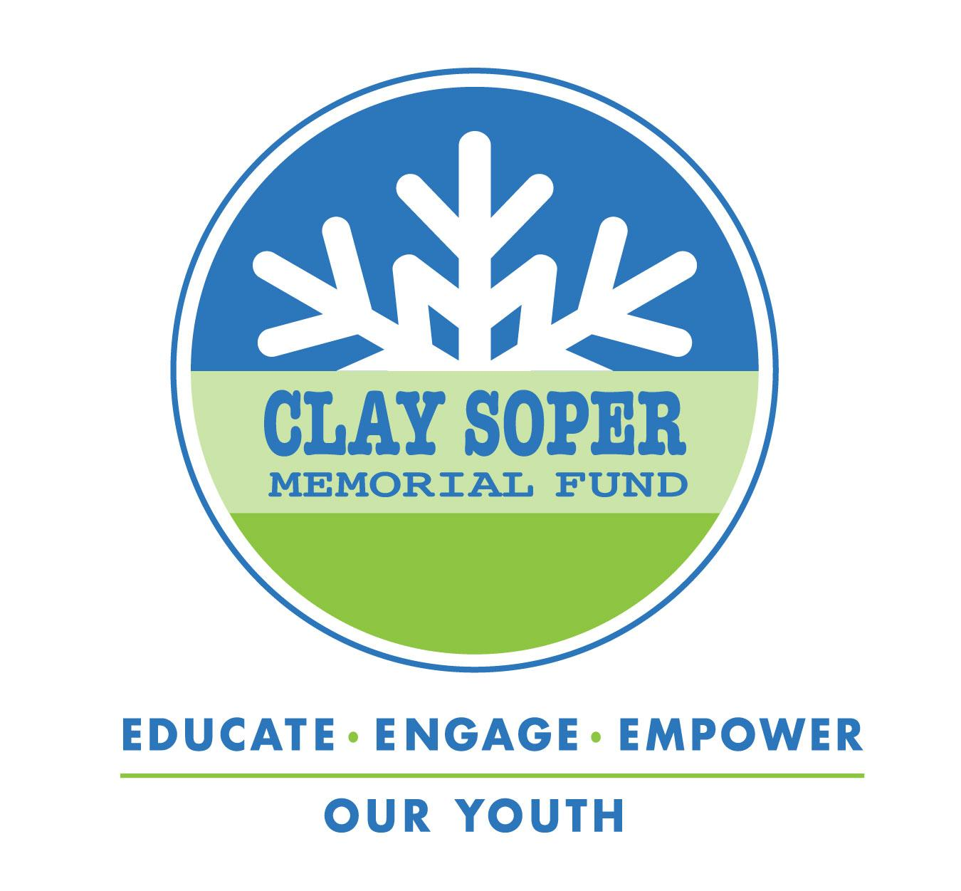
PRESS RELEASE
FOR IMMEDIATE RELEASE

MEDIA CONTACT: Kristi Young
kyoung@claysopermemorialfund.org
(877) 729-2763 ext. 3
.

With one in five high school seniors reporting that they have misused prescription drugs, reaching our youth early is now more important than ever.

[Month, Date, 2023 Town, State] - Through partnerships with schools, community organizations, and business leaders, the Clay Soper Memorial Fund is making a lasting impact on the health and well-being of the [name of the town(s)] residents in [state(s)] by bringing the documentary program "If They Had Known" into their schools. In the 35-minute film, we share the story of Clay Soper's tragic, accidental death from mixing prescription drugs with alcohol. The film, combined with the Program Toolkit, catalyzes peer-to-peer discussions about the risks surrounding the recreational misuse of prescription drugs in our youth’s party culture and provides our teens with life-saving information.

Teen fatality due to prescription drug misuse is rising. In addition to the recreational misuse of prescription drugs, teens who suffer from stress and depression turn to prescription drugs to self-medicate. There is an alarming increase in deadly overdoses from fentanyl among young people. Teenagers unknowingly purchase Fentanyl-laced prescription pills on the street and through social media. “If They Had Known” educates and empowers our young people with life-saving information. The film recounts the last night of Clay Soper's life. On July 18, 2015, 19-year-old Clay Soper and his teenage friends gathered for a house party. They were ready for a typical night of fun. During the party, Clay and some other partygoers mixed Xanax with alcohol. For Clay, it was a lethal mixture that caused his respiratory system and heart to stop. No one at the party knew combining prescription drugs with alcohol could be fatal. "If They Had Known" is not about drug addiction or substance abuse. It’s an honest account of a death that shouldn't have happened. The life-saving message comes from Clay's friends and peers, not actors. The takeaway is genuine and impactful. The documentary, combined with the Program Toolkit, provides teens with information that could save their life or the life of a friend.

“If They Had Known” is a program of the Clay Soper Memorial Fund, a 501(c)(3) nonprofit. The mission of the Clay Soper Memorial Fund is to educate, engage and empower today’s youth with life-saving information about the risks of misusing and abusing prescription drugs and to help motivate cultural change among young people. For more information on how to license the documentary program, please visit claysopermemorialfund.org. For parents and families interested in viewing "If They Had Known," individual rental is available on Amazon and Google Play.

PO Box 102 Winchester MA 01890 claysopermemorialfund.org 877-729-CSMF (2763) © 2023 Clay Soper Memorial Fund

